EVS Short Term
Puzzled Training Course


Radovljica, Slovenia

June 14-20, 2003

Table of Contents
 | Page
Introduction | 3

Background of the EVS Short Term Puzzled Training Course | 4
Definition of Needs | 5
Aims of the Puzzled Training Course | 5
Expected Results | 6
Specifying “Less Opportunities” and Defining the Profile of Participants | 6
Homework Assignment for Participants | 7
Role of the National Agencies | 7
Educational Approach | 8

Daily Programme | 9-22

Summary of the Participants’ Final Evaluation Questionnaire | 23/24
Team Evaluation | 25/26
Useful Contacts and Websites | 27

I. Checklist for Sending Organisations | 28/29
II. EVS Short Term Puzzled Training Course Programme | 30
III. List of Participants | 31-33
IV. Just for Fun | 34/35

Introduction

This report is a summary of the EVS Short Term Puzzled Training Course held in Radovljica, Slovenia from June 14-20, 2003. It is aimed at youth workers, youth organisations, National Agencies, and other individuals working to promote the inclusion of less-opportunity young people in European-level activities, and specifically within the European Voluntary Service Short Term programme (Action 2 of the European YOUTH programme).


The report is divided into three sections:

Part I aims to provide background information on the origins and development of this training course. Individuals looking for information about the needs, aims, target group, and expected results should refer to this section.

Part II takes a more detailed look at the daily programme of the training course. An introduction to each session is provided, along with a description of the different methods used. The results from the various sessions and examples of feedback taken from group discussions can be found here. Please note that some results have been presented in the forms of Appendices at the end of this document (refer to the Table of Contents for details).

Part III presents the results of the course evaluation. A summary of the participants’ comments is included here along with an overview of the team’s final evaluation and their recommendations for future events.

We hope that the information in this report will be used by organisations and individuals alike to become better acquainted with the EVS Short Term programme. By instructing a wider audience about the potential of this exchange programme, we hope to stimulate the participation of more less-opportunity youngsters in EVS Short Term.

We also hope that this report will help the Puzzled participants relive the warm summer days spent in Radovljica. So in the words of the Puzzled theme song, let’s take a look…. “One More Time!”


* The puppet on the cover page were made by the youngsters in PUM (Projenktno Ucenj Za Mlajse Odrasle - Radovljica). This puppet is named Tomas!

Background of the EVS Short Term Puzzled Training Course

The Puzzled Training Course organised by MOVIT Slovenia is the third in a series of international training events of the same name. The Puzzled programme aims to inform organisations about the possibilities offered by the European Voluntary Service (EVS) Short Term programme to young people with less-opportunities.

Launched in 1998, the European Voluntary Service programme offers young people aged between 18 and 25 years the chance to spend up to 12 months abroad. The young people contribute their time and skills on a voluntary basis to support a local social project. In the first years of the programme, it quickly became apparent that students and young people with previous experience abroad were quick to recognise how participating in EVS could be a means of improving their personal and professional development. However, for so-called “less-opportunity young people” (those less used to travelling abroad, those with less exposure to foreign cultures, those with less access to information, those with lower-level education, those from economically deprived regions, etc.) the barriers to participating in EVS proved to be too high.

In the year 2000, the EVS programme was integrated into the current phase of the European YOUTH programme. At this time, an important change was made to EVS. In response to the lack of participation by less-opportunity youngsters, the programme was adapted so as to make the programme more accessible and more appealing to these youngsters. The EVS Short Term programme was created – offering young people the chance to go abroad for shorter periods of time and offering financial provisions for youngsters with special needs. Yet even these changes did not serve to significantly increase the participation of less-opportunity youngsters. It seemed that there was still a considerable lack of understanding on organisational level about the potential benefits of EVS. There was also a certain amount of disbelief and suspicion among youth workers, some of whom felt that in spite of the new changes, EVS remained too difficult and “not for their young people”.

In response to this, the Dutch and Flemish National Agencies (NIZW and JINT) organised the first EVS Short Term Puzzled event in February 2000. The training course aimed to help youth workers discover how and why EVS Short Term could be used as a method with the target group. The title of the training course was chosen in response to the confusion expressed by both youth workers and by young people themselves; people who had little or no experience of international voluntary work were quickly “puzzled” by the concept of EVS Short Term and did not easily see how to use this method. The course programme was developed along this theme; in order to know how best to use EVS Short Term, organisations need to understand the different puzzle pieces, the different aspects of the programme, which need to be fit together in order to complete the final puzzle picture of EVS Short Term.

The first Puzzled event was followed two years later by a second Puzzled Training Course held in Poland, November 2002, organised by the Polish, Dutch, Belgian and Portuguese National Agencies. The approach and methods used in the first Puzzled training course were developed further. At the conclusion of the Polish Puzzled course, participants felt much more confident about their level of understanding of the EVS Short Term programme and were enthusiastic about taking the first steps towards starting new Short Term exchanges. In spite of this, the total number of exchanges that have actually been implemented so far (one year after the training) remains relatively low.
Definition of Needs

A preparatory meeting was held in Ljubljana from May 2-4, 2003. Representatives of the three National Agencies involved in the event took part in the meeting, including Bartek Mielecki of the Polish National Agency, Kristina Tihanova of the Latvian National Agency, and Barbara Zupan of the Slovenian National Agency, MOVIT. Also in attendance were two independent trainers; Kathy Schroeder (Schroeder Intercultural Consulting, the Netherlands), and Ansgar Bueter-Menke (AHA Media Production & Training, Germany)

The Slovenian Agency, MOVIT, had been trying to set up EVS Short Term projects for several years. An international contact-making seminar had been held in 2000 to try to bring like-minded organisations together and to initiate new partnerships, but few concrete projects had come out of the seminar. In spite of this, the Agency recognised that the EVS Short Term programme offered a valuable opportunity to young people who would not otherwise have the opportunity to travel abroad. MOVIT felt the next step would be to offer a training course to try to examine the potential of EVS Short Term in more detail.
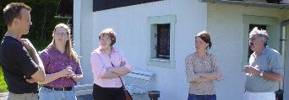

Two participants from Slovenia attended the Puzzled training in Poland in 2002. Their feedback from the course, as well as their proposals for new projects, clearly demonstrated how the Puzzled course programme fit in with MOVIT’s national strategy. As a result, MOVIT decided to host the third in the series of Puzzled Training Courses in June, 2003.

The Polish Agency felt that the participation of experienced persons from the Dutch and Flemish Agencies had been vital to the success of the Polish Puzzled event. As such, they felt it was important to act as the link between the past event and this latest training course. The Polish Agency also planned to send participants to the Puzzled, and as such it would be useful to have a representative of their own Agency present. The Polish Agency remains committed to creating new projects for less-opportunity youngsters.

In Latvia, the National Agency had sent two volunteers on EVS Short Term projects to date. The Agency was interested to become more involved in EVS Short Term exchanges. They saw the Puzzled training as an important opportunity for their Agency to learn more about this programme in order to stimulate more exchanges for young people in Latvia.

Aims of the Puzzled Training Course

The aims of the training course were defined as follows:

- To help youth workers learn why and how to use EVS Short Term as a method in their regular work and as a step along the larger pathway with their young people
- To identify how EVS Short Term can benefit a young person or an organisation
- To initiate new EVS Short Term exchanges
- To help participants learn how to set up a quality pedagogic framework for EVS Short Term exchanges
- To help participants anticipate problems within EVS Short Term and to learn how to address them
- To create new European-level partnerships
- To introduce other possibilities in the European YOUTH programme

Expected Results

At the conclusion of the training course, it was expected that participants would:
- better comprehend EVS Short Term as a method; have a better idea of when and how it can best be used with the target group
- have gained more confidence in their practical skills and knowledge relating to EVS Short Term
- have concrete ideas for new EVS Short Term projects
- have taken the first steps towards new partnerships between organisations
- have learned how to work in partnership with their National Agency (as a valuable partner in the exchange process)
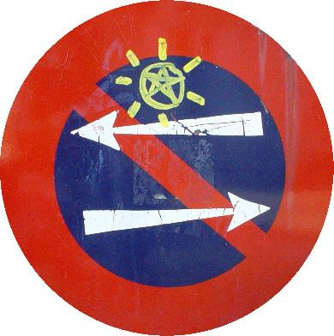

On the long-term, it was expected that participants would:

- carry out quality pedagogical EVS Short Term projects
- use other Actions in the YOUTH programme as a means of preparing their youngsters to take part in EVS Short Term
- establish successful long-term European-level partnerships
- multiply the information received during the training course to young people, colleagues and other contacts
- be in a position to integrate other aspects of international youth/social work on local level

Specifying “Less Opportunities” and Defining the Profile of Participants

The EVS Short Term programme targets so-called “less-opportunity” young people. This is a term which encompasses many different types of youngsters. A young person may be deemed to have “less opportunities” on the basis of their geographical location (i.e. living in rural or isolated areas), on their level of education, on their ethnic and/or religious background or on the basis of their economic situation. At the same time, young people with physical or mental disabilities may also be considered as having “less opportunities” when compared with other able-bodied youngsters.

Plainly, this term includes a wide range of characteristics, which do not always easily relate to each other. It would be extremely difficult, and certainly inefficient, to try to consider all the different needs of this range of youngsters in one training course. Faced with this situation, the team decided to concentrate on issues relating to youngsters faced with less opportunities due to their social and/or economic circumstances. This group could include, for instance, young people who left school early, who lived in poor areas, and who had few opportunities for employment. Young people from immigrant backgrounds could also be included in this group, depending on their social situation.

Once the profile of the youngsters had been narrowed down, it became easier to identify which types of organisations would most benefit from this training course. Several important aspects would be taken into account during the recruiting process. It was said that participants should:

- be motivated to learn more about the possibilities offered by the EVS Short Term programme;
- be well-acquainted with the target group of socio-economically disadvantaged youngsters;
- have direct experience in working with this target group on a daily basis;
- be able to communicate and to work in English;
- be ready to actively take part in all aspects of the seminar and in particular to contribute information and real-life examples taken from their own experience with the target group;
- be mandated by their organisation to explore and initiate potential partnerships during the seminar;
- be committed to following-up new partnerships and projects once the seminar has ended.

Homework Assignment for Participants

The EVS Short Term programme is a potentially useful tool for many young people. However, sending a young person abroad as a volunteer can be a complicated undertaking. Given that the training course would only last 6 days, the team decided to use this limited time to help participants understand the complexity of EVS Short Term as a tool within youth work and not to discuss the administrative aspects of the programme (e.g. application procedures, deadlines, finances, etc.). As such, it would be up to the National Agencies to ensure that their participants had been introduced to the technical side of EVS Short Term before they arrived at the training course. As well, participants were given a small homework assignment. Each participant would be asked to present not only their own organisation, but also had to be ready to talk about which types of youngsters were considered to have “less opportunities” in their own country, why, and what sort of possibilities existed for these young people. This special preparation would be used at different moments in the training course programme.

Role of the National Agencies
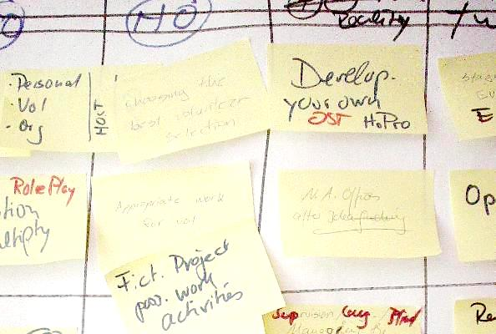
The first three years of the EVS Short Term programme have indicated that one factor which may be blocking participation is the application procedure. Many organisations are intimidated and confused by the series of applications to be made and by the lengthy administrative procedures. Smaller grass-roots organisations in particular may not have previous experience in project planning and grant writing, and are easily discouraged from continuing with the programme. As such, the National Agencies can play an important role as facilitators within the EVS ST programme. They can advise organisations how to set up a quality pedagogical experience for volunteers. They can help new organisations learn how to formulate the language in their application so as to improve their chances of being approved. Perhaps most importantly, the Agencies can help to keep organisations and their young people motivated through the (sometimes long) approval process.

Since the success of an EVS Short Term project depends heavily on the support of the National Agencies, it was very important to help the participants get to know the Agency representatives attending the training course. The team aimed to show that the people working in the Agencies can be valuable partners in the EVS process. To help establish this partnership, the three Agency representatives committed to attending the training course full-time. To avoid giving the impression that they were “observing” or “policing” the participants, the representatives were integrated into the course as much as possible. They were frequently used as “experts”; they were asked to give examples from their own national experience with EVS ST, to answer questions during discussions, and to play an active role in several exercises.

Educational Approach
While the Puzzled programme is referred to as a training course, it should be noted that the trainer team adopted an educational approach of non-formal learning. As such, the course programme was designed so that participants could learn with and from each other. Several simulation exercises were used to help participants become immersed in the reality of less-opportunity young people and the challenges that this reality poses for EVS Short Term exchanges. Time was allocated after each session to allow participants to exchange opinions and experiences. The Agency representatives as well as the trainers contributed to this process by relating their own experiences within the EVS Short Term programme, so as to avoid too much theory and to keep the programme “real”. This regular input of real-life experiences was an integral part of the training course and was seen as being vital to the success of future exchange projects. The programme also included space for daily evaluation and personal reflection. Regular feedback from this evaluation helped the team to alter and structure the programme so as to best respond to the needs of the group without losing sight of the established aims and expected results.

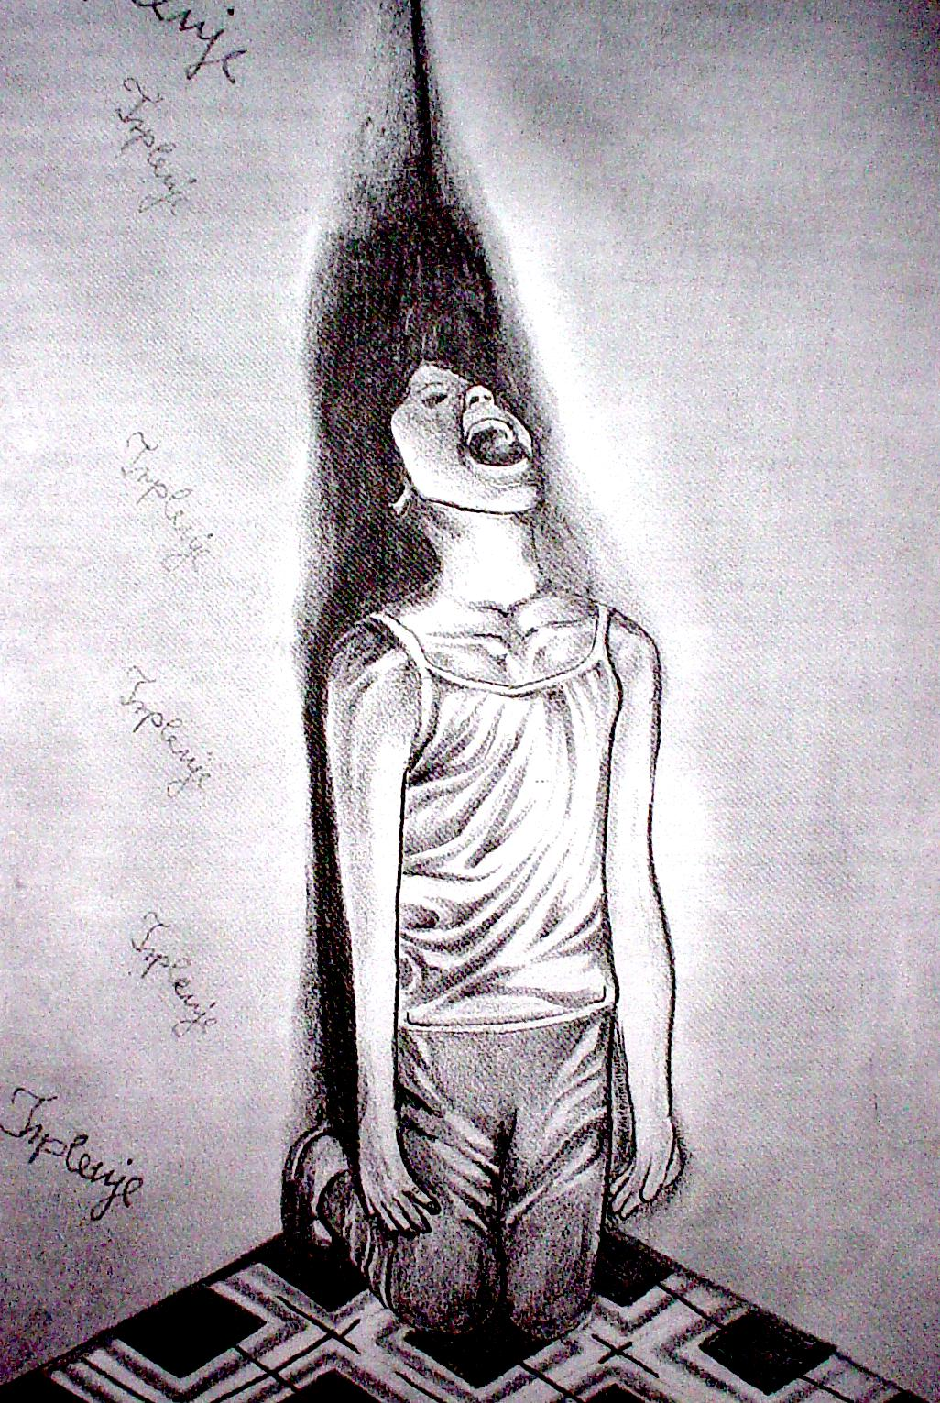
Drawings from Natǎsa Varmaz, Youth center Radovljica.
The picture was taken from her report titled: "When the Wealth is Not Put in Your Cradle". Natǎsa won a prize for the article in a contest called "PoorYoung People in Slovenia."

Daily Programme

Saturday – Getting to Know Each Other
Evening programme 20:30 – 21:30

Welcome evening
A series of icebreakers and name games was used during the first evening to help participants get to know each other, including one group exercise where participants had to work together to complete a large jigsaw puzzle. This helped to introduce the theme of the course, namely, to examine separate pieces of EVS Short Term and to fit the appropriate pieces together in order to have a complete picture by the end of the event.

Participants had also been asked to do some “research” before the evening session. Each person was given two words which they had to learn in Slovenian before the start of the training course. It was hoped that in this way participants could take their first steps towards getting to know the host country. A dictionary of useful words and phrases was put together during the icebreaker session (see Appendix IV). The welcome evening concluded with a round of Slovenian wine enjoyed under a starry sky.

Sunday - Motivation and Identification
Morning Programme 09:00 – 12:30

Introductions
The morning started with a short warm-up game to help the participants recall all the names they had learned the night before. Next, the participants were officially welcomed by Janez Skulj, Director of MOVIT (the Slovenian National Agency). The team members then introduced themselves, and briefly described their function and previous experience with the EVS Short Term programme and with less-opportunity youngsters.
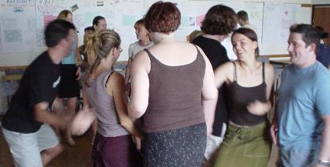

Expectations
The trainer team was aware that the level of understanding of EVS Short Term was likely to be very different among participants from different countries, each of whom had different levels of experience of the YOUTH programme in general. Therefore an important first step in the programme was to take an inventory of the participants’ previous knowledge, experience, and needs. As a first step, each person was asked to take 15-20 minutes to fill in a written intake questionnaire. Participants were asked to describe how well they felt they knew the EVS Short Term programme, what they wanted to learn and what they hoped they would take away.

A sample of the participants’ responses is included here:

- I want to learn about the important factors that make EVS-ST a success
- New contacts and partnerships
- Gain a clear view on when, why and how motivate the youngsters to go abroad for EVS-ST
- Get new ideas
- Better knowledge of EVS-ST
- Start to build up a network
- Learn new working methods
- Find out more about how we can play the role of host organisations
- To learn enough in order to be able to handle the needs of the ST target group
- To know what my organisation should do to be well prepared to send and
- host less opportunity young people
- Gain enough inspiration and motivation in myself to be able to establish EVS in my own organisation
- Make plans for future projects

As a second step, the group was asked to express what they expected from the course. Participants were asked to respond to the following four questions and to write their answers on a corresponding cut-out shape:

- What I hope will happen during the course - a star
- What I can contribute to the course - a hand
- What I hope to carry home with me after the course - a bag / rucksack
- What I hope to avoid during the course - a stinky sock

Once everyone had finished, the shapes were hung on a long clothesline for everyone to see. The group was given time to elaborate on what they had written. Finally, the team members responded to the ideas expressed.

The Situation of Less-Opportunity Young People in my Country
The EVS Short Term programme is aimed at less-opportunity young people. However, the term “less opportunities” does not necessarily have the same meaning in different countries. Given the high level of diversity among the participants, it was important to spend some time getting to know the specific national situations of less-opportunity youngsters in the different countries. In this way, the group could begin to see the wide variety of meanings attached to the term “less opportunities” and become more aware of the country-specific problems they face.


Participants were asked to make a short presentation describing the situation of less-opportunity youngsters in their own country. Participants were divided into national groups and were asked to respond to the following questions in their presentations:

“Young People with Less Opportunities”
- Who are these young people? How are they excluded from “normal” society? Where can you find them?
- How do YOU work with these youngsters in your country? What approach or philosophy do you use? What structures exist? Do you use any unique methods?

Example: Country Presentation - Belgium
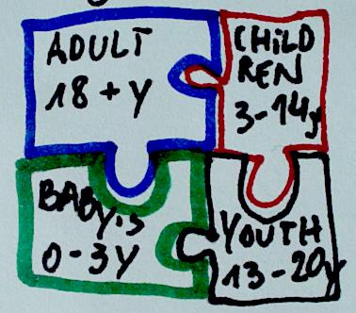
Who are the less opportunity younsters in Belgium?
- young immigrants and the children of immigrants
- »4th world« youngsters
- the new poor
- youngsters with emotional problems
- youngsters with disabilities
How are they excluded?
They are excluded from regular society because for different reasons they don't find a place within the social structures (for example school, welfare, health care...) They don't have access to social networks (sport clubs, youth organisations, …)
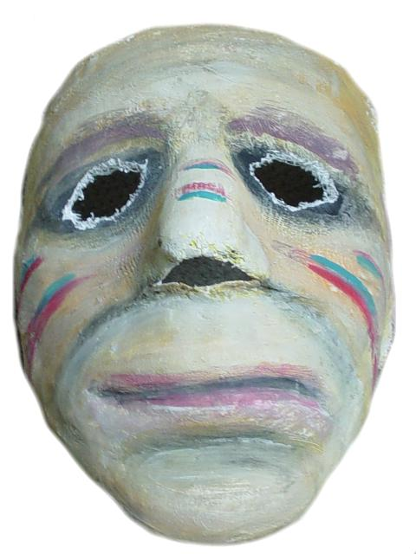

Where can you find these youngsters?
- On the street
- In schools / second chance education
- Girls in particular are very hard to reach (especially girls from immigrant families)

Different goverment departments have financial resources for disadvantaged youth
(e.g.: education, culture, sports, youth). But it's hard to offer continuity on any level because the government departments don't like to give money for professional staff costs. There is money in project-forms, but this often becomes a one-off system. Structural money is hard to find.

Current philosophy within Belgium:
- There is a strong intention to make moves towards inclusion
- There are discussions to start a union for youth workers
- Learning through action is an important theme at the moment.

Pathways in my organisation

A guiding principle throughout the course was the idea that EVS Short Term should not be seen as an end in itself. Rather, EVS Short Term should be seen as a potential tool to be used by organisations to help their young people move forward along their individual pathways. In keeping with this principle, participants were asked to look at the structure of their regular work in their own organisations in order to identify how they currently help their young people grow and develop.


To demonstrate the idea, one of the team members gave an example of a typical pathway of the youngsters in his organisation. The pathway was symbolised by puzzle pieces fitting together – showing the beginning, middle, and end of cooperation with the organisation. Next, participants were asked to do the same – to use puzzle pieces to show how a youngster moves from one stage of their pathway to the next within the organisation. The following questions were given as a general guideline:

- When do young people come into your organisation?
- What steps or processes do the young people follow in your organisation?
- When do young people leave your organisation? How do you know it is time for them to leave?

The group was given approximately 30 minutes to depict their puzzle pathways. Once completed, the pathways would be integrated into the organisation presentations during the afternoon session.
Sunday Afternoon 14:30 – 18:00

Presentation of Organisations

The afternoon session was largely devoted to exchanging information about the various organisations present at the training course. Participants were asked to make a poster presentation describing their organisation’s aims and activities, their previous experience with the target group and their own function within the organisation. The puzzle pathways which had been made earlier in the day were also integrated into the presentations. These pathways showed the steps the organisation uses to help a young people move forward in their lives.
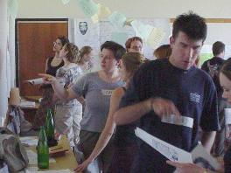

Once the posters were completed, participants were divided into small groups to make their presentations. After approximately 45 minutes, the groups were reorganised for a second round of presentations. In this way, each participant presented their own poster twice, and listened to detailed presentations from approximately 1/3 of the rest of the group. This system of presentation was seen as only the starting point in a longer process. At the conclusion of the second round, all the posters were displayed in the plenary room. It was stressed that the creation of new partnerships was the responsibility of the participants, so the group was encouraged to take time to read those posters they had not yet seen, to make contacts and to ask questions throughout the training course.

Reflection Groups

At the end of the day’s programme, participants were split into Reflection Groups. The aim of these groups was to provide space for a more casual exchange of reactions and feedback between the team and the participants. Each group was assigned a member of the team, and it was left to each group to choose their own discussion topics. Time for reflections groups was reserved at the end of each day (the groups remained fixed throughout the course). A mid-term evaluation was also carried out in the reflection groups on the third day of the programme.
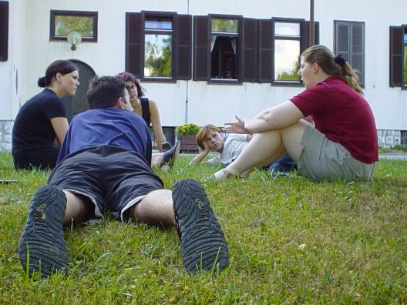

Intercultural Evening

At the end of the first day’s programme, participants were invited to take part in an intercultural evening where a variety of national food and drink specialities were offered. The festivities carried on until the early hours. Some national highlights included Irish toasts, typical Latvian costumes and a Polish sing-a-long.
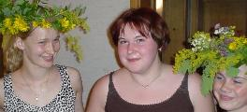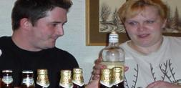

Monday – EVS Sending Issues
Morning Programme 09:00 – 12:30

Development of the EVS Short Term Programme

The second day of the programme shifted the focus to the EVS Short Term programme itself. The first step in getting to know EVS ST was to understand the origins and evolution of the programme.
A member of the team made a brief presentation on the development of voluntary work since the First and Second World Wars. International voluntary work inside Europe in the 1980’s and 1990’s was characterised by the participation of many young people under the age of 25. As such, some projects began to adapt to accommodate the specific needs and interests of young people in order to make their projects more appealing to this age group. European Voluntary Service (EVS), a programme which was launched at the end of the 1990’s, can be seen as a unique form of voluntary work which offers possibilities and conditions for young people to work as volunteers which had previously not been available inside Europe.
EVS Short Term is a small part of the larger EVS programme. EVS ST was developed specifically in response to the lack of participation of less opportunity youngsters in the traditional EVS programme. But it is important to note that EVS is a pedagogical programme. This means that there must be a strong educational aspect within the voluntary project; EVS is not meant to provide cheap labour to social projects and NGO’s. The pedagogical element is a fundamental aspect of EVS Short Term and is an important starting point when planning any EVS ST exchange.

Brainstorm on the benefits of EVS ST
The aim of this session was to look closely at the EVS Short Term programme and to try and imagine the concrete benefits of a volunteer exchange project.

Participants worked in small groups and brainstormed what they thought EVS Short Term could bring to:
- the young people in their organisation
- to their organisation
- to themselves as an individual inside the organisation

The results are compiled below:

Benefits for the young people

To see how other youngsters cope with the same problems | To get to know they are not alone, gain a new point of view on their situation | To be a foreigner
Overcome their fears | To escape from the shit at home | To feel needed
To come in contact with other cultures | Make new friends | Informal education
A way to become more independent | Do something they can be proud of | Improve their language skills
Gain more self-esteem and self-confidence | Improve their social skills | Believe they can change things
Travelling to other countries

Benefits for the organisation

Get to know other organisations | Make new aquaintances and learn other methods of working | Intercultural learning
More publicity | Exchange experiences on international level | Feel working in Europe
Start partnerships for other EU projects | Be a part of a Europe-wide network | After EVS, they have motivated youngsters to work as volunteers in the home organisation
Gain an international image in the community and maybe also more local money

Benefits for me as a youth worker

Learn new skills, knowledge, experience, development | Broaden my own horizons | Learn about international networking
Satisfaction about the youngsters' development | Have the chance to travel (to project partners) | Exchange ideas
Learn project-writing skills | Gain knowledge about other systems/concepts | Intercultural learning
Make international friendships | Improve my English skills / have the chance to learn a new language | Make contacts all over the world

Presenting EVS

Taking the first steps towards EVS Short Term can be difficult, particularly when young people and/or organisations hear about the programme for the first time. Past experience has shown that it can be difficult to capture the imagination of young people – they may not automatically be enthusiastic about the idea of going abroad on their own to work for free. Similarly, youth workers may not be convinced of the usefulness of the programme, or may feel that they already have too much work to do. This session aimed to help participants see which approaches to presenting EVS work more effectively than others.

Participants were split into small groups. Two rounds were held - each group was asked to act out one role play and to act as observers during the second role play. Using the results of the brainstorm as a guideline, one member of the first group had the task to present the EVS Short Term programme to a group of young people (who had also been given roles in advance). In the second group, one member had the task to present EVS to their colleagues in the organisation (each of whom also had separate roles). At the end of each role play, the players and observers were given the chance to react on the approaches or key words they felt had worked well and on those which had been less successful.

A sample of the points which arose during discussions after the role plays:

→Comments from participants playing the young people:
- Can I trust the partner organisation abroad? How well does my sending organisation know them? How well does my youth worker know my new contact person?
- Why is this a good opportunity for me?
- If there are too many options, it can be intimidating, but don’t limit my choices either.

→Comments from participants playing the organisations:
- How much money do we get for this activity? Is it going to cost us anything? The financial aspects are very important.
- How much time will it take? It is just extra work and we already have too much to do
with our limited resources.
- What is the point in spending so much time on one youngster when we are working with many young people? Isn’t it unfair to use so many resources for only one individual?

Two points were made during the debriefing. In spite of the fact that the benefits of the programme had been listed on paper only minutes before the role play, those points were seldom used during the role plays. This is a good demonstration of how difficult it can be to keep the information ordered in your own mind, and also how important it is to be well prepared before making such a presentation in real life. It was also interesting to see how few participants had thought to use the pathway aspect in their presentation. If youngsters and/or youth workers can see the place of EVS Short Term within a larger pathway, they are likely to be more receptive to the idea.

Monday Afternoon 14:30 – 17:30

Obstacle Course
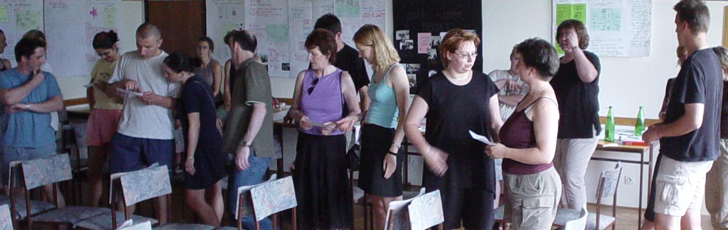
Once a young person decides they would like to take part in an EVS Short Term exchange, there is a lot of preparation to be done before they can depart. However, no matter how enthusiastic a young person may be about going abroad as a volunteer, there are many unseen factors in the background which can seriously affect less-opportunity youngsters and which may in fact prevent them from taking part in EVS.

To highlight some of these factors, the participants were given profiles of different types of less-opportunity young people. Using these profiles, the participants were then lead through a series of obstacles which often need to be dealt with in the preparation phase. Participants were given the task of determining whether the profile they had been given would be blocked by specific obstacles, or whether those obstacles were potentially serious enough to stop them from going on an EVS Short Term exchange. At the conclusion of the exercise, the profiles and the obstacles were examined and discussed in detail. It was important for the participants to understand the potential obstacles which may confront their young people in order to be better prepared to deal with them should they arise.

Checklist for Sending Organisations
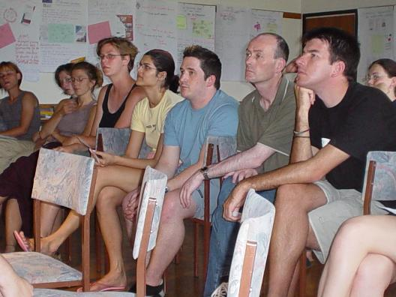

Using the knowledge gained during the Obstacle Course exercise, the participants were given the task to come up with a list of points which must be investigated or organised by the Sending Organisation before a young person can be sent abroad on an EVS Short Term exchange. The results were compiled into one final Checklist for Sending Organisations (see Appendix I).

Tuesday – EVS Hosting Issues
Morning Programme 09:00 – 12:30

Aspects of a Hosting Project

When setting up a host project for a new volunteer, organisations typically concentrate on developing daily work activities for the young person. But it is also important to remember that there are other aspects which contribute to the success of a hosting project. How can a hosting project be set up so as to best respond to the needs of a less opportunity young person? What needs to be taken into account? How can the different aspects of a host project contribute to the pedagogical development of a less opportunity youngster?

A series of four stations was set up. Each station dealt with a specific aspect of a hosting project:
- Appropriate Work Activities
- Types of Accommodation
- Free Time Activities
- Language and Communication Issues

In each station, the participants received some theoretical information on each theme. More importantly, each station took time to examine the impact of each aspect on the target group of less opportunity youngsters. Some of the issues discussed included:

Work activities: What type of work activity is appropriate for a volunteer?
What type of work activity is realistic for an EVS Short Term project?
How does the work activity relate to the individual’s personal pathway?

Accommodation: Which forms of accommodation are most suitable?
How can the form of accommodation contribute to the personal development of a less opportunity young person?

Free time: Why is spare time an important aspect of the EVS experience?
What possibilities exist?
Is the host project responsible for organising a youngster’s spare time?

Language: What is the difference between language and communication?
Does a young person require language skills to be able to carry out the work activity?
What resources do you need to handle communication problems?

The discussions which took place in this exercise would be touched on again on Wednesday morning when the participants would be asked to put together their own hosting project.
Visit to a Local Project - PUM (Projektno Ucenje Za Mlajse Odrasle - Radovljica)

To gain more insight into the situation of less-opportunity youngsters in Slovenia, the group was invited to visit PUM, an organisation which provides assistance and support to early-school leavers, unemployed youngsters and individuals with difficult home situations. PUM offers a variety of activities to youngsters in the area; they also work together with various government departments to support the youngsters in obtaining their school certificate in order to eventually find work.
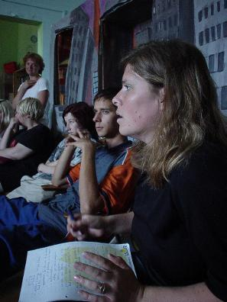
A representative from PUM had taken part in the Polish Puzzled training 8 months earlier. PUM was now very interested in starting new EVS Short Term exchanges. They were preparing to host their first volunteer, a young man from the Netherlands. They were also trying to find host organisations abroad to take their young people. The staff recounted how they had not found it difficult to motivate their young people to go abroad. Many of the youngsters had never had the chance to travel abroad before and were quite enthusiastic. The other staff members had also quickly grasped the usefulness of EVS Short Term and saw how the programme could be used to compliment their regular work. However, their biggest obstacle was trying to find organisations willing to host their youngsters. It seems that even like-minded organisations are hesitant to host, usually because they were nervous about taking on the responsibility and extra work involved with a vulnerable young person. The PUM staff also spoke candidly about the difficulty of staying motivated through the long application process.

The group was given time to meet and speak with the young people in the project. It was a good opportunity for some participants to make contact with so-called less opportunity young people for the very first time. Making a visit to PUM at this stage in the programme was extremely useful, as it helped participants put real faces and personalities onto the theory they had learned during the previous days. Learning about the real situation of a project like PUM also reinforced several concepts which had been discussed earlier, namely the importance of using EVS Short Term within an individual’s pathway, dealing with obstacles, choosing appropriate work activities, etc.

Tuesday Afternoon 14:30 – 17:30

Selecting a Volunteer - Making the Right Match

One potentially difficult task of the host organisation is to select the most appropriate young person for the EVS Short Term exchange. What is involved in this selection process? On what basis should organisations make their choice?

To explore these questions, the participants took part in an exercise called “Make the Right Match”. Participants were split into three small groups. Each group received a description of a fictional host project as well as motivation letters from three interested volunteers. Each motivation letter was supplemented by information from the volunteer’s sending organisation. Using this information, the groups had to choose which of the three young people would be best suited for this host project.

The discussions around this selection were very animated. Many issues were raised and hotly debated within the group. At the conclusion of the exercise, the team stressed that although it is easy to imagine all that the volunteer can give to the organisation, it is much more difficult to imagine what the organisation can give to the volunteer. Host organisations should ask themselves: how can we help this young person advance along their pathway? What can they gain from their time with us? Is this a big enough challenge for this young person? These questions will help is making a more appropriate selection.

Wednesday – Developing an EVS Short Term Project
Morning Programme 09:00 – 12:30

Develop a Potential Host Project

At this stage of the programme, it was time to take the theory learned and apply it to the current situation in the participants’ own organisations. As a first step towards creating new partnerships and new EVS Short Term projects, the participants were asked to try and design a potential host project based on the real situation and needs in their own organisations.

Participants worked in groups of two. For the purposes of the exercise, it made no difference if people were planning to be host organisations in future or not. The process of working out an appropriate and interesting host project is useful for both sending and hosting organisations, as it focuses attention on a variety of important details within the project itself.
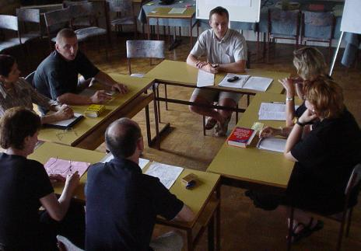
Between the two persons, one project had to be selected to be developed. The participants were asked to work out a host project for a new volunteer which had to include a description of:
  - the volunteer’s work activity
  - the proposed accommodation
  - possible activities for the volunteer’s free time
  - an example of a typical week’s schedule for the volunteer (Mon-Fri)

After taking approximately one hour to discuss and develop the project, the partners were asked to briefly present their project in front of four other participants and one representative of the National Agencies. At the end of the presentation, the group and NA were asked to give feedback on the proposed project. Some examples of issues raised during this exercise are shown here:

Proposal
A vocational training school is interested to host an EVS ST volunteer. The students in the project left normal school at a young age and are now following a 2-year programme to try to become qualified in a trade (e.g. blacksmith, carpenter, etc.) They attend the school from Monday-Friday. They are closely monitored throughout the day – they all have a defined programme which is strictly observed, including when they eat, when they have free time, when they have to be back in their rooms in the evening and when it is “lights out” at night. A volunteer who is interested in working with their hands will be invited to join the students in their regular course programme – the volunteer can try out a variety of different building skills.

→Comment – Work Activity: At the moment, this proposal seems to be rather far away from the EVS philosophy of volunteering. There is no description of how the volunteer works to help the local community, only that they could learn some skills. EVS ST is not the same as vocational training! Also, it is unclear how this proposal would fit into a young person’s pathway. What will learning about blacksmithing contribute to their personal growth? And how will they use those skills when they return home? Is the work activity not simply a means to keep the volunteer busy and off the streets? The pedagogical aspects need to be thought out more clearly.

→Comment – Free Time: The strict daily routine of the school is probably too restrictive for most volunteers. Keep in mind that although they may be defined as less-opportunity youngsters, the volunteers are in principle adults, and may have difficulty fitting into such a system. And if the volunteer did ask for more freedom, would this not cause problems among the students (it might seem that the volunteer enjoyed a special status that they did hot have).

→Comment - Accomodation: a positive aspect is that the volunteer is part of a large group throughout the week. However, on the weekends, the students return home, the school is closed, and the volunteer is alone. It is precisely the weekends which need consideration (so that the volunteer does not feel isolated). Another aspect to be considered is whether it would benefit the volunteer to live in such a protected environment where the shopping, cooking, etc, is done for them. This environment might be suitable for extremely vulnerable youngsters, but an alternative should be provided for those who are more independent.

The exercise proved to be a real eye-opener for many participants. In some cases, the proposals were subjected to strong criticism if it was felt that the project was not suitable for less-opportunity youngsters. In particular, having to make a detailed plan for an entire week drew people’s attention to how challenging it can be to organise enough work activities to keep a volunteer busy and to provide activities which are interesting work to keep the volunteer motivated. At the end of the session, one of the Polish participants commented “Now I know how I can be well-prepared for the realisation of our future EVS ST project. Especially the details, for example about accommodation or working activities, I had underestimated them.”

The feedback from the National Agencies proved invaluable in this exercise. Participants gained a clearer idea of what distinguishes a volunteer project from a course of study or paid work. The group learned what needs to be included in a project proposal, and which aspects of their current ideas needed revising. This stage of sounding-out potential project ideas was an important step in building up a partnership between organisations and the National Agencies.

Wednesday Afternoon 14:30 – 16:00

Extra Time for Information on Participating Organisations

During the Reflection Groups held the previous day, participants had said that they would like more time in the programme to get to know more about the different organisations attending the training course. The programme was adjusted to allow an extra hour and a half for presentations. A schedule was organised so as to allow people to visit a maximum of organisations in the allotted time frame.
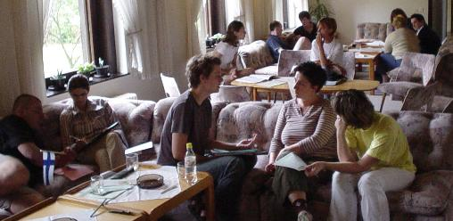

Excursion to Bled
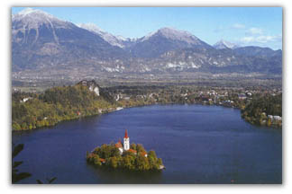
The group made a visit to Bled, one of Slovenian’s best known tourist attractions. After a visit to a famous castle, the group split up; some people went souvenir hunting while others tried to beat the heat by swimming to the church in the middle of the lake. The day was rounded off with a typical Slovenian meal and a visit to the local bars (but only the diehards made it that far!)

Thursday – Future Plans
Morning Programme 09:00 – 12:30

Follow-Up – What Happens After EVS Short Term?

One of the most important but often overlooked phases of an EVS ST exchange is the return home. In this phase, it is up to the Sending Organisation to follow-up with the volunteer. Often, organisations carry out a final evaluation with the volunteer and think that their work is done. However, the evaluation of the EVS experience itself is only the tip of the iceberg. The next steps include reintegrating the volunteer back into daily life and helping them plan for the future.

To highlight some of the issues which can come up in the follow-up phase, the participants were split into groups of 3. Each group was given a short description of the case of a fictional volunteer. Some groups were asked to examine the case from the point of view of a Sending Organisation while others took the view of the Hosting Organisation. The task was to define what the responsibilities of the Sending and Hosting Organisation could be in each situation. After approximately 20 minutes in the small groups, a Sending was put together with a Hosting group and asked to make an appropriate “action plan” for their volunteer.

At the conclusion of the exercise, it was clear that there may be many levels involved in the follow-up of less opportunity youngsters, depending on their situation. It was also surprising for some participants to see to what extent the Hosting Organisation could play an active role in supporting both the volunteer and the Sending Organisation during the follow-up process.

Final Sending and Hosting - Market
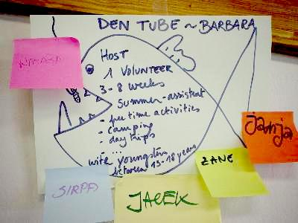

As the training course began drawing to a close, it was time to help participants organise their ideas for new projects and to facilitate the exchange of information between organisations.

New projects were advertised in the form of a large market. Each participant wrote out their project proposals on a paper in the form of a fish (one fish per project idea). The market was purposefully left open; participants were free to propose EVS Short Term project ideas (possibilities for hosting, or potential young people looking for a project abroad, etc), but they could also propose other activities within the YOUTH programme. These “extra” activities were seen positively, as they can be good starting points for long-term partnerships, and can lead to EVS at a later stage.
The EVS ST fish were displayed on one side of the room, while all other project proposals were hung on the opposite side. Once all proposals were completed, the participants were given time to circulate and read the ideas on offer. If they saw an idea which appealed to them, they wrote their name on a Post-It note and stuck it onto the fish. This took quite some time as a considerable amount of projects had been proposed. After a set amount of time, the market entered the next stage: contact-making. Each person returned to their fish and then had to seek out those persons who had expressed an interest in cooperating (all those who had stuck Post-Its). This process took quite some time, so the market was continued through the lunch break and into the afternoon session.

Future Action Plan
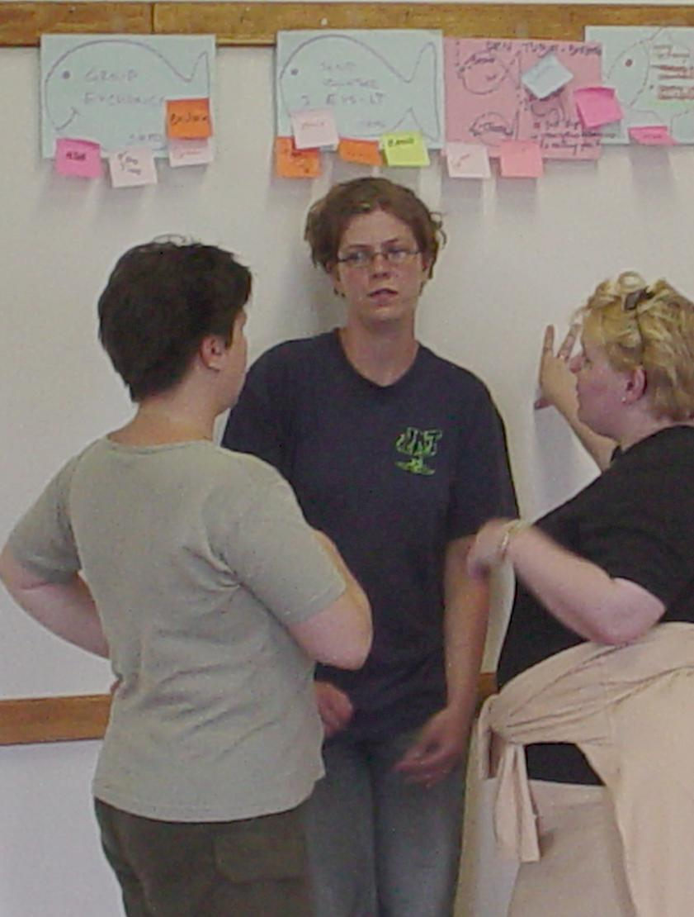

At the conclusion of the fish market exercise, participants were given some time to organise the outcome of all their discussions. The group was asked to indicate what new ideas for future projects had come out of the training course. Some of the proposed projects are described here:

- EVS long term exchanges in Latvia with Belgium, Ireland and Finland
- Sending an EVS ST volunteer to Finland
- A German-Austrian project in an outdoor resort
- I would like to host a volunteer in Slovenia, but so far I only find one potential SO
- Sending and Hosting from Slovenia to Belgium
- Sending and Hosting from Belgium to Ireland and Austria
- Recruiting some volunteers for summer activities
- Sending a volunteer from Poland to Manchester, England
- A possible youth exchange (Action 1) in 2004 to be hosted in German with Ireland, Belgium and Finland also participating

Evaluation

The training course was evaluated in three steps. First, the participants were given their Intake Questionnaire which had been completed on the first day of the course. They were asked to refer to this intake while they filled in a written evaluation, in order to see to what extent their expectations and needs had been met.
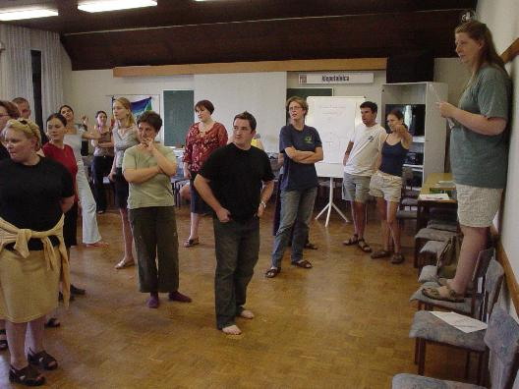
Once the questionnaires had been completed, the technical aspects of the course were evaluated. For this, the Plus/Minus method was used. A member of the team stands on a chair in the centre of the room. Various technical points are named one at a time (e.g. the food and accommodation, the seminar house, the free time, working in English, etc.) Participants take a space in the room according to how they evaluate each point – towards the left if their reaction was positive, towards the right if their reaction was negative. After each point, people were given the chance to make comments.

To round off the evaluation and the training course as a whole, a large jigsaw puzzle was placed in the middle of the floor. Each participant was asked to take a piece which represented something personal for them about the course or the time spent in Slovenia. Each person was given the chance to explain the symbolism of their puzzle piece and replace it on the floor. When the puzzle was completed for the last time, the training course was officially closed. (For more details from the Evaluation session, please refer to Part III.)


Summary of the Participants’ Final Evaluation Questionnaire

“The most important is to go abroad and do something useful!”

Personal Level
Have your expectations been met during the seminar?
17 of 18 participants said that their expectations were met completely, or they were even exceeded. (one person wrote nothing). Some participants explained why: they received new information, made contacts and learned many practical things about the responsibility involved in being a HO or SO for ST-Volunteers. One participant wrote that she felt able to give new information to her organisation.

Now that we’ve come to the end of the Puzzled training, how well do you feel you know the EVS Short Term program?
- I understand EVS-ST much better now than before;
- Well enough to prepare my young people for something new;
- I know what the responsibilities of the HO & SO are;
- I understand the skeleton of the YOUTH program and where I can get more detailed information;
- Most important is to go abroad and do something useful;
- I need to work out my ideas more precisely;
- The aims are clear
- I could know more (2);
- I have more insights in the specific preparation, support and follow up of ST-EVS;

What have you learned about EVS-ST? Please be specific!
- What problems I can encounter; to be prepared that something goes wrong
- the deep impact that I can have on a persons life in a relative short period of time and that it can be a positive experience (I was really critical about this);
- that it’s completely different from EVS-LT and therefore you should prepare it differently (3)
- if you know the procedure, it’s possible to do
- about different types of young people who would prefer EVS-ST
- how to deal with language problems
- how to decide that my young person is ready to do EVS-ST
- 4 different important things in hosting: work schedule, free-time, accommodation and support
- necessity of openness and cooperation between SO and HO

What do you think you have contributed to the training? (In discussions, inside the participant group, in the free time,...)
- because of my language problems not so much (2)
- gave real examples of my day-care centre
- shared my ideas and knowledge about youth, my experience as an ex-volunteer (3)
- in the very good discussions in the free time
- some humour, jokes, laughs, not only about work (4)
- Because of my young age (18) I have not so much experience. But anyway I tried to represent my organisation
- Little look on the Polish system of support for young people

What are you taking away from the seminar? (Name the most useful information or skills that you gained)
- Networking and partnerships (3)
- If something goes wrong, I don’t take it personally or as a critic
- Project ideas / How to write a project / new skills / a lot of information
- The importance of personal contacts to make things like EVS-ST or Youth-exchange
- More confidence of the importance of the work we all do
- Inspiration and motivation (3)
- The circumstances in other countries about youth and social care systems (2)
- Friendships and addresses
- Some kind of obstacles which are in the EVS
- Lot’s of team spirit and intercultural learning
- That there are more pathways for disadvantaged youngsters that I thought

Have you made plans for some future projects? Please describe the kind of project and with whom?
- EVS-LT Latvia with Belgium, Ireland and Finland
- Sending EVS-ST to Finland
- A German Austrian project in an outdoor resort
- I would like to host a volunteer in Slovenia but I only find one SO
- Sending and Hosting from Slovenia to Belgium
- Sending and Hosting from Belgium to Ireland and Austria
- Some volunteers for summer activities
- Sending a volunteer from Poland to Manchester
- A possible youth exchange in 2004 in Germany with Ireland, Belgium and Finland
- Yes, but nothing set in stone

Team
Was it useful for you to have representatives of the National Agencies here during the training? Why or Why not?
- Yes, because Bartek was very helpful for me (a Polish participant)
- Yes, it was useful they helped to clarify things in my own country (a Latvian participant)
- It was useful to a certain extent, but having 3 persons from other countries was limiting for me. I missed having someone from my Agency present here (a UK participant)
- Yes, for theoretical and practical things (3)
- Yes, for translation (2)
- Thanks to Barbara for her wonderful job
- Provided every information we need (Slovenia)
- Yes, but maybe one person is enough
- Good for concrete questions about the procedures, also to find out about other Actions
- Not sure (an Irish participant)
- Yes, for their experience

How do you feel the trainers managed their role?
- Very good and engaged (3)
- Both were just perfect
- Very helpful and clear
- Very interesting and interactive way of learning, with lot’s of humour and good music
- They weren’t boring
- Always an open ear for all kind of problems or experience (2)
- The training was following the group and it was good (5)
- Very well – but a bit regimental
- In an informal, but strict way

Other Comments
- It was very helpful to have evaluation every evening, so the training was “living” when we wanted so
- maybe make the days shorter
Team Evaluation

At the conclusion of the training course, the team members held a separate evaluation meeting. The team read through all the participants’ evaluation questionnaires and reacted to some of the comments written. After discussing various points, each person in the team was given the opportunity to make their own personal evaluation of the training course and the cooperation among team members.

Preparation and Recruitment Phase
During the recruitment phase, it had proved very difficult to find participants for the training course, in spite of the best efforts of many National Agencies. The minimum number of participants was reached just shortly before the course was to begin. Because of this, it is likely that the participants’ profile which had been defined during the prep meeting was not strictly observed. As a result, the team had to cope with several problems. Firstly, some participants had only very basic English skills and could not follow the course without having other participants or team members translate for them. Secondly, the last-minute calls for participants also resulted in some people being selected who did not have direct experience with socio-economically disadvantaged youngsters. Some of these were very new in their jobs and had not yet been exposed to the target group. Others came from organisations with a completely different profile but who interested in broadening their work to include socio-economic less-opportunity youngsters. Ultimately, all the participants were able to learn a great deal from the course, but it was a challenge to keep the course content relevant for everyone.

The difficulty in finding participants also contributed to a lack of preparation ahead of time. It had been hoped that participants would received information about the administrative and application procedures involved in EVS Short Term. For many, this was not the case, so some time was reserved in the programme for a short explanation; this session was called “EVS for Beginners”. The Agency representatives also did their best to answer questions about EVS ST procedures during breaks and in the evening. The team felt that the need for preparation in advance should be stressed in future, as it is extremely difficult for participants to keep up if they lack even the most basic information about the EVS programme.

The Course Programme
The team felt that the training course had been highly successful in motivating new organisations to participate in EVS Short Term. However, there is still a lot of room for improving the course programme. The Puzzled training course was specifically designed to serve as an in-depth introduction to EVS Short Term. As such, many details were not dealt with in this course (due to time restrictions), but they could be included in future events if the programme was extended by 1 or 2 days.

The trainers were praised for their high level of flexibility and for their willingness to adapt the programme so as to best suit the needs of the participants. The reflection groups at the end of each day were a good method for monitoring the atmosphere among the participants.

The team felt that the Puzzled training had been very successful in making the theory behind EVS Short Term more “real” for the participants. The programme made an effort to juxtapose the theory behind EVS ST with the real-life situation of less opportunity youngsters in as many sessions as possible. One important part of this process was the session on Developing a Potential Host Project and in particular the feedback received from fellow participants and from the Agencies during this exercise. The team felt that this session had served to wipe away some illusions about volunteer projects and had clearly shown how complex EVS Short Term can be. Another useful session was the visit to PUM. It was here that some of the participants first came into contact with the target group and could hear first-hand about the difficulties they face in finding a placement.

The team noticed a similarity between this and previous Puzzled events in terms of the future projects which were being proposed. It was interesting to note how many participants want to try an Action 1 group exchange or want to experiment with EVS Long Term as a preparation for EVS Short Term. One conclusion that can be drawn from this is that the Puzzled course has been successful in impressing the complexity of EVS Short Term onto participants. It should be seen as a positive sign that organisations take their responsibilities seriously and want to proceed slowly and professionally as they build up to developing exchange programmes for less-opportunity youngsters.

The Structure of the Training Course
It was stated that one important factor contributing to the success of the training course was the composition of the team. One of the trainers had had considerable experience in the preparation and evaluation of less-opportunity youngsters within the EVS ST programme, while the other trainer was additionally a youth worker who had already sent and hosted several youngsters on EVS ST exchanges in his own organisation. This combination in the team of trainer had a very positive effect on the programme as a whole, as each of them were well acquainted with the strengths and weaknesses of the EVS programme from different points of view.

The presence of the three Agency representatives was also vital to the success of the Puzzled course. Their contributions made a good impression on the participants and definitely served to strengthen the relationship between Agencies and organisations. It was said that in future events, the Agency representatives should be used even more actively within the programme.

One factor beyond the team’s control was the extreme Slovenian summer weather during the training course. The high temperatures (+35º C) caused some difficulties on the first day, as it was just too hot for people to work in the seminar rooms. While the heat played havoc with the team’s planning (many sessions had to be readjusted so that they could be held outdoors), the participants were overjoyed at having the opportunity to get a suntan while working.

Summary of team recommendations for future EVS Short Term training courses
- More attention needs to be paid to the recruitment and selection of participants for this type of training course. The participant profile should be more carefully observed.

- Participants should be well-informed about the administrative and application procedures for EVS ST before arriving at the seminar. If it is not possible to adequately prepare people on national level in advance, then the length of the course needs to be increased so that these procedures can be properly explained.

- The combination of a professional youth worker with a professional trainer should be considered for future EVS ST training courses.

- The active participation by representatives of the National Agencies was an important factor in the success of this training course.

- Given the diversity of experience and expectations among participants, the team must remain flexible and be ready to make adjustments in the course programme when necessary.

- It takes time for organisations to prepare themselves to take on EVS ST exchanges. As such, they should be encouraged to use other activities (e.g. group exchanges, EVS LT) as steps towards building up strong partnerships and an understanding of voluntary work before starting projects with potentially vulnerable young people.

Useful Contacts and Websites

- Slovenian National Agency of the YOUTH Programme
“MOVIT; NA Programa MLADINA”
Trg Mladinskih delovnih brigad 12, SI-1000 Ljubljana, Tel.: +386.1.426.52.69
www.movit.si/mladina

- Polish National Agency of the YOUTH Programme
“Foundation for the Development of the Education System”
ul. Mokotowska 43, PL-00-551 Warszawa, Tel.: +48.22.622.3706
www.youth.org.pl

- Latvian National Agency of the YOUTH Programme
“Agency for International Programs for Youth”
Jaunatne Eiropai, Merkela 11-531, LV-1050 Riga, Tel: +371.721.32.02
www.yfe.lv

- European Commission – YOUTH Programme – Users’ Guide to the YOUTH Programme:
www.europa.eu.int/comm/education/youth.html

- Partnership between the European Commission and the Council of Europe – Educational publications (T-Kits, Coyote):
www.training-youth.net

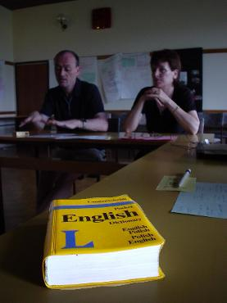


Checklist for Sending Organisations

I. Administration
Find a suitable project
Passport / ID
Investigate whether a work permit / residence permit / or visa (for non-Europeans) is necessary
Organise insurance
Finalise contracts / preliminary agreements between SO / HO
Hold a preparation meeting with the volunteer
Check in with other relevant institutions (police, social institutions, social benefits office, etc.) to see if arrangements must be made
Establish who will be the “mentor” in the sending organisation

II. Family / Friends
Get family permission for the volunteer to travel
Supply contact information to the family (e.g. telephone numbers, e-mail address)
Keep the family informed
Set up a plan for keeping contact
Hold a preparation meeting for family and friends (to show pictures, videotapes, etc) before and after the project. Invite family/friends to pre-departure meeting
Organise a farewell & welcome party

III. Travel
Contact the embassy to inform them about the project and to fix necessary documents
Check if a volunteer has passport, tickets and all other necessary documents
Send someone more experienced before you send a volunteer
Arrange a preparation visit with a volunteer in a HO
Go and stay with a volunteer in the first few days of a project
Buy the tickets together
Make the detailed plan for travel to the HO, what things to bring (clothes, shoes, maps, guides, dictionary, etc.)
Check if the volunteer has appropriate luggage
Give written instructions for travel and a map
Arrange for somebody to pick up the volunteer at the airport, bus station, etc.
Propose taking a lunch packet
Give phone numbers in case of emergency (mobile phones)
Advise the volunteer to take something to shorten the journey (books, music, etc.)
Information about expected prices

IV. Finances
Explain the sharing of responsibilities between HO and SO (travel costs, preparation visit, living costs in another country, pocket money, give some tools for fundraising)
Explain how the HO/SO gets the money
Arrange all social benefits
Show samples of the host currency
Explain what amount of money they can spend (for food, for bills) and how they can spend (different ways of spending)

V. Health
Check if the volunteer has any serious illnesses or health conditions (asthma, epilepsy, etc.)
Inform HO about the volunteer’s medical/mental history and needs (addiction problems,…)
Make sure that a volunteer will be able to buy their medicine or that they take it with them (including contraception, condoms, etc.)
Sexual education
Promote all health issues (vaccinations, personal hygiene)
Check if a volunteer is fit to travel
Set up the health insurance and be clear about what is covered and what is not
Explain how to handle medical situations and what procedures should be followed (e.g. importance of AXA insurance card, keeping receipts, etc.)
Making sure the volunteer is physically able to do the work activity proposed by the HO
Check with the HO if they have specialists on staff able to deal with serious mental disorders (if applicable).

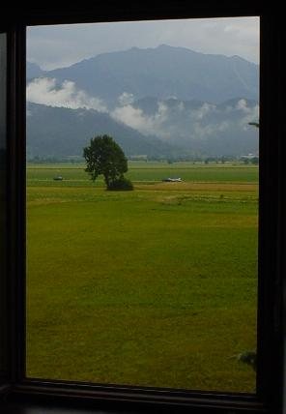

Appendix II – EVS Short Term Puzzled Training Course Programme

 | Motivation and Clarification | EVS-send | EVS host | Develop a new EVS | Future plans
Saturday 14.06. | Sunday 15.06. | Monday 16.06. | Tuesday 17.06. | Wednesday 18.06. | Thursday 19.06 | Friday 20.06
 | - Welcome from Janez  - Presentation of the course. aims, objectives, program  - Explore expectations  (Socks, backs, hands & stars)  - Feedback on this  - Exclusion in my country & how do you work with them | - History of EVS  - Benefits from EVS ST to a young person? To my org.? To me?  - Role play for promoting and multiplying EVS-ST (youth + colleagues)  - EVS for beginners (Techn. questions) | - Join the stations:  - Appropriate activities, accommodation, spare time, language  - Visit to a local H.O. for ST-EVS | - Improving your exposé EVS ST host project within other pax & N.A.’s | - What happens when the volunteer is back?  - Final Sending & Hosting - Market  Space for partnership proposals and further discussions | DEPARTURE OF  PARTICIPANTS + TEAM
 | Lunch Break | Lunch Break | Lunch Break | Lunch Break | Lunch Break
ARRIVAL OF  PARTICIPANTS | - Pathways of a young person in my organisation  - Open fair of your youth organisation (part 1) | - Obstacles in EVS ST before you send them  (pair exercise)  - Make a check list for the prep phase | - Selecting a volunteer  (group exercise)  - Exposé for your EVS ST host project | - Organisation presentation (part 2)  - Group excursion to Bled | - Future action plan  - Evaluation
 | Reflection groups | Reflection groups | Reflection groups
Dinner | Dinner | Dinner | Dinner | Dinner | Dinner
Getting to know each other  - Name & guesture  - slovenia for begin.  - finger & hands  - 2 truth, 2 lies | IC evening | Free evening | Free evening | Group excursion to Bled | Farewell party

Appendix III

List of Participants

EVS PUZZLED TRAINING

Radovljica, Slovenija, 14 – 20 of JUNE 2003

 | No. | Participant's name | Organisation / County | Tel., E-mail
 |  | Philip Daly | Lourdes Youth & Community Services (L.Y.C.S)  c/o Lady of Lourdes day care centre  Mc Dermot St.  Dublin I  Ireland | *353 1 836 34 16
 |  | Alice O'Keeffe | Sullivans Quay School  Sullivans Quay  Cork  Ireland | *353 21 4316826  info@boomerang-theatre.com
 |  | Barbara Van Dael | Jongewerkinh Den Tube  P/a Paul Delavauxwijk 2  3000 Leuven  Belgium | *32 (0)16206591  *32 (0)484125697  dentube@hotmail.com
 |  | Lennart D'hulst | AFS vzw Interculturele Programma's  Br. Whitlocklaan 132  1200 Brussel  Belgium | *32 2 7358525  lennart.dhulst@afs.org  www.afsvlaanderen.be
 |  | Carmen Luger | SCI: Moers ggmbh  Barbarastr. 12  47443 Moers  Germany | *49 2841 95790  jugendsocialzentrum@sci-moers.de
 |  | Sandra Reek | VFBJ Ausbildungverein  Wirtschaftsstr. 4e  23972 Gros Stieten  Germany | *49 3841 790028  Vereinsleitung@VFBJ.de
 |  | Zane Peigazne | Social Work Agency of Kurzemes district – Youth Day center  Vaidelotes 13  Riga, LV –1055 - Latvia | *371 7466855  A.Veidemanis@kurzeme.rcc.lv
 |  | Laila Eiduka | Student project initiative center  Zellu 8-602  Latvia | *371 1 9118395  lailaeiduka©yahoo.com
 |  | Alex Fairweather | Toucan – millenium volunteers  Manchester  United kingdom | *44 161 2735122
 |  | Elisabeth Barnfeind | Rettet das Kind  Raiffeisenplatz 11  A-5340 St. Gligen  Austria | ingrid.wengbauer@rettet-das-kind-sbg.at
 |  | Sirpa Alapiessa | City of Oulu, Youth affairs department  p.o. box 16  90015 Oulun kaupunki  Finland | *358 44 7038252  sirpa.alapiessa@ouka.fi
 |  | Niina Holmstrom | Siuntio Municipal  Krouvinties 1  02580 Siuntio  Finland | *3589260611  niina.holmstrom@siuntio.fi
 |  | Zieba Jacek | GIANT, The Family support Society  Gliwice  Poland | *48 32 238 24 55  akecaj@poczta.onet.pl
 |  | Anna Brzezinska | Mlodziezowe Centrum Profilaktyki Alternatywa  Leszno  Poland | *48 (065) 529 74 95  bas_brzezinscy@poczta.onet.pl
 |  | Janja Kozorog | Mladinski dom Jarše  Stanovanjska skupina Črnuška gmajna  Suhadolčanova 57  1231 Ljubljana/Slovenija | *386 154143434  janja_kozjirog@hotmail.com
 |  | Nataša Smole | Klub študentov dravinjske doline  Žička cest 004/a  3210 Slovenske konjice  Slovenija | *386 3 759 13 20  msservis@siol.net  natasasmole@yahoo.com
 |  | Doris Ravšl | Mladinski center Trbovlje  Rudarska cesta 5  Trbovlje  Slovenija | *386 3 56 31 018  mct@siol.net
 |  | Kristina Golob | Zavod Janeza Smrekarja, OE Skala  Rakovniška 6  1000 Ljubljana  Slovenija | *386 1 427 14 19  skala@salve.si
 | 19. | Kathy Schroeder | trainer | kathy.schroeder@planet.nl
20. |  | Ansgar Bueter-Menke | trainer | Ansgar.Bueter@t-online.de
21. |  | Bartek Mielecki | NA Poland | b.mielecki@youth.org.pl
22. |  | Kristine Tihanova | NA Latvia | kristine.tihanova@latnet.lv
23. |  | Barbara Zupan | MOVIT; NA programa MLADINA  Trg Mladinskih delovnih brigad 12  1000 Ljubljana  Slovenia | *386 1 426 52 69  program.mladina@mladina.movit.si  barbara.zupan@mladina.movit.si

Appendix IV
Just for Fun…

Slovenian Dictionary

Good morning - Dobro jutro Good night - Lahko noč
Goodbye - Nasvidenje Coffee with milk - kave z mlekom
Thank you / you’re welcome - Hvala / Prosim Beer - pivo
My name is… - Mo ime je… I come from… - Prihajamiz…
Where is…? - Kje je…? How are you? - Kako si?
A shop - Trojovina Bus station - Autobus postaja
Lunch - Kosko Dinner - Večerja (vecherya)
Youth programme - Mladina Young person - Mladljudje
It is very hot - Zelo je vroce

Ukraina

Hej, tam gdzieś znad czarnej wody
Siada na koń Kozak młody
Czule żegna się z dziewczyna
Jeszcze czulej z Ukrainą

Hej, hej, hej sokoły
Omijajcie góry, lasy, pola, doły
Dwzoń, dzwoń, dzwoń dzwoneczku
Mój stepowy skowroneczku
Hej, hej, hej sokoły
Omijajcie góry, lasy, pola, doły
Dwzoń, dzwoń, dzwoń dzwoneczku
Mój stepowy dzwoń, dzwoń, dzwoń

Ładnych dziewcząt jest nie mało
Lecz najwięcej w Ukrainie
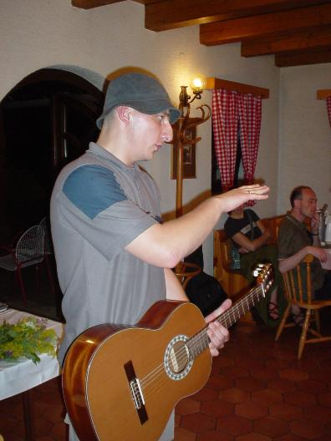
Tam me serce pozostało
Przy kochanej mej dziewczynie

Hej, hej, hej skoły…

Ona jedna tam została
Jaskółeczka moja, moja mała
A ja jeden w obcej stronie
Dniem i nocą tęsknię do niej

Hej, hej, hej sokoły…

Żal, żal za dziewczyną
Za kochaną Ukrainą
Żal, żal serce płacze
Już cię więcej nie zobaczę

Hej, hej, he sokoły…
The text of this report has been compiled from contributions from the team members of the EVS Short Term Puzzled Training Course and edited by:

Kathy Schroeder (Schroeder Intercultural Consulting).

Graphic design and lay-out were provided by:

Ansgar Bueter-Menke (AHA Media Productions and Training).

The opinions and statements expressed in this report do not necessarily reflect the opinion of the European Commission or of the National Agencies involved in this event.

This report has been written on behalf of
MOVIT,
the Slovenian National Agency of the European YOUTH programme,
and produced with the support of the
European Commission
and the
Ministry of Education, Science and Sport of the Republic of Slovenia.

The EVS Short Term Puzzled Training Course was hosted by MOVIT and financed through Action 5 of the European YOUTH Programme. The organisers would like to thank the participating National Agencies for their support of this event and in particular the
Polish National Agency
for their contribution to the programme costs.

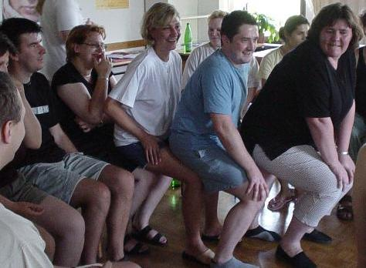
 “One More Time!” 

